COREX PROGRAM USER’S MANUAL

Introduction

The Corpus Gesproken Nederlands is a database of recordings and annotations that will eventually contain 10 million spoken Dutch words. The Corex program allows you to listen to, view and analyse the Corpus.

This manual describes the Corex program commands. It is organised in a sequential manner based on the windows and panels that open up in the program. The following is a list of the Corex windows and panels and their corresponding sections in this manual:

1 Corpus Browser window
2 Session Viewer
2.1.2 Wave Panel
3 Search Dialogue Panel
4 Statistics Dialogue Panel

Contents

Introduction 1
1. Corpus Browser Window 3
1.1 Corpus Gesproken Nederlands Directory 3
1.2 Font Size Menu 4
1.3 Search button 4
1.4 Statistics button 4
2. Session Viewer 5
2.1 View Menu 5
2.1.1 Audio Player 5
2.1.2 Wave Panel 7
2.1.3 Visible Tracks 7
2.2 Options Menu 8
2.2.1 Praat Synch 8
3. Search Dialogue Panel 9
3.1 Track Selection menu 10
3.2 Regular Expression Search 10
3.3 Add Criterion 10
3.4 Add Query 11
3.5 Delete Query 11
3.6 Start Search and Close buttons 11
4. Statistics Dialogue Panel 12
4.1 Track Selection menu 12
4.2 Start Search and Close buttons 12

1. Corpus Browser Window

In the Corpus Browser window you can view and access the directory of the Corpus Gesproken Nederlands (CGN), which contains the hierarchy of Sub-Corpus folders and Sessions (see illustration below). In addition there are two buttons at the bottom of the Corpus Browser window that allow you to initiate Searches and do Statistical counts of the CGN.

Corpus Browser Window options
1.1 Corpus Gesproken Nederlands Directory
- Sub-Corpus folders
- Sessions
1.2 Font Size
1.3 Search button
1.4 Statistics button

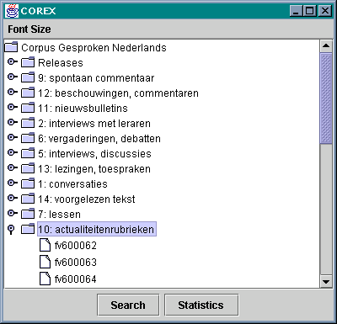
CGN Directory

Sub-Corpus folders
(with classification numbers and names)

Sessions

1.1 Corpus Gesproken Nederlands Directory

The CGN Directory contains the Sub-Corpus folders which are displayed when the Corpus Browser window initially opens up. If the Sub-Corpus folders are not visible, double click on the CGN Directory icon to display them.

Double click on a Sub-Corpus folder to open it up and display the Sessions contained within it. Each Session has a corresponding CD containing the audio files. In order to use the Corex Audio Player or Wave Panel features with individual Sessions, you require the Session CD (i.e. to use the Audio Player function with Session r1nl_02, you must have the CD labelled CGN_r1nl_02 in the CD drive).

Double click on the Session you want to work with and a viewer panel opens showing the Session’s transcription text (see section 2. Session Viewer).

1.2 Font Size Menu

This menu gives you four choices of font size with which to view the text. These are: 12, 14, 16, and 18 point. Changing the font size in the Browser window will effect all the Corex windows and panels.

1.3 Search button

At the bottom of the Corpus Browser window is the Search button. Click on the Search button to open up the Search Dialogue Panel (see section 3. Search Dialogue Panel).

1.4 Statistics button

The Statistics button is also located at the bottom of the Corpus Browser window. Click on the Statistics button to open up the Statistics Dialogue Panel (see section 4. Statistics Dialogue Panel).

2. Session Viewer

A Session Viewer is a view panel showing blocks of transcribed utterances for a selected session. (see illustration below).

Each block contains the following: a timecode marking the beginning and the end of the utterance and a alpha-numeric label identifying the speaker (e.g. N00050). In some cases the word comment appears instead of the speaker identification number (this indicates that the utterance is a comment made by the transcriber).

A vertical red bar appearing to the left of an utterance indicates it is the selected block. Occasionally two utterances will have the red bars beside them because in some cases neighboring utterances have the same media timecodes.

All utterance movements are synchronized between the Session Viewer (which encompasses the Audio Player) and the Wave Panel (see section 2.1.2 Wave Panel for details).

Viewer Window options
2.1 View menu
2.1.1 Audio Player
2.1.2 Wave Panel
2.1.3 Visible Tracks
2.2 Options
2.2.1 Praat Synch

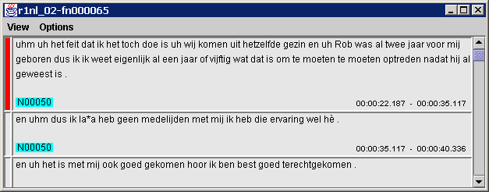
Red bar indicates the selected block
Timecode for the beginning and end of the utterance
Label identifies the speaker or the text as a transcriber comment.
A block of transcribed text (containing an utterance).

2.1 View Menu

The View menu contains three selections; Audio Player, Wave Panel, and Visible Tracks.

2.1.1 Audio Player

Select the Audio Player option (View menu) and you are prompted to insert the corresponding CD into the CD drive. At the prompt, click the OK button and the Session Viewer is slightly modified (see illustration on the following page). There is now a new bar directly beneath the menu bar that contains a media time counter, a scroll bar with a play/stop button, a speaker icon, and a media properties icon. Click on the play button to hear the transcription text. All Audio Player movements within the utterances are synchronized with the Wave Panel display.

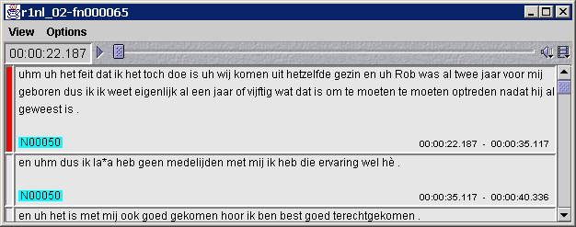
Media Properties icon
Play/stop button
Speaker icon
Scroll bar
Media time counter
(hours: minutes: seconds: hundredths of seconds)

Media properties icon

- The media time counter displays the media time location in the transcribed text (see illustration above). Double click on the time counter box and a Go To window opens up allowing you to enter a new media time. The Session Viewer adjusts the position in the transcription text automatically according to the new time you specify and displays the selected text.

- You can use the scroll bar to change your location in the transcription text.

- There is a play/stop button at the left end of the scroll bar (see illustration above). Click on the play button to begin the audio player. Once it commences, the play button changes to a stop button (two parallel vertical bars).

- The speaker icon, located at the right end of the scroll bar (see illustration above), can be used to adjust the volume level or to mute the sound altogether. To adjust the volume click on the icon with the right mouse button and a scrollable volume bar will appear. To mute the sound, click on the speaker icon with the left mouse button and a line will appear through the icon, indicating the sound has been muted.

*If you are having an audio problem, first make sure your speakers are turned on and that the speaker icon does not have a line through it.

- For technical information about the media properties, click on the icon at the far right end of the scroll bar to open the Media Properties window (see illustration above). This window contains three sections: General, Audio, and Plug-in Settings. To view the contents of a specific section, click on the appropriate tab heading and the information will be displayed.

2.1.2 Wave Panel

When you select the Wave Panel option (View menu), a window opens up showing the transcription text as a waveform (see illustration below). The Wave Panel is synchronized with the Session Viewer (which includes the Audio Player), so that any adjustments to the utterance location made in one will also be made in the other. For example, double clicking the media time counter in the Audio Player and entering a different media time will change the utterance location. The Wave Panel will simultaneously reflect the new location and display the appropriate utterance waveform.
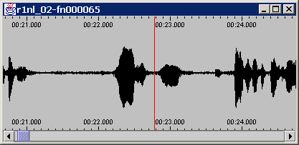
Location indicator bar
Media time is indicated above & below the waveform.

- Identical media time indicators are located above and below the waveform.

- You can use the scroll bar to change your location in the transcription text.

- A vertical red line moves along the waveform, marking the current media time. You can click on any part of the waveform to move to that location. The waveform location is synchronized with the selected utterance in the Session Viewer.

- You can change the resolution of the waveform using the arrow keys on the keyboard. Use the left arrow on to zoom in, and the right arrow to zoom out.

2.1.3 Visible Tracks

There are four different options (tracks) for viewing the transcibed text: Orthography, Part Of Speech, Lemma, or Marked word. Orthography is the default track. Under the Visible Tracks option (View menu) you can select individual tracks or any combination of tracks. A checkmark appears in the box beside selected tracks in the Visible Tracks menu option (see illustration below).

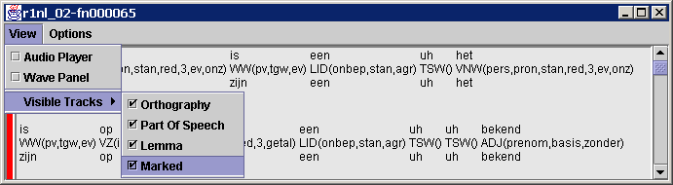
You can select any or all of these tracks
(e.g. here all four tracks are selected)

It is also possible to view all tracks for individual words in the utterance. To do so, point to the word with the mouse, click on it and hold down the right mouse button. The tracks for the text you have selected are displayed for as long as you hold down the right mouse button (see illustration below).

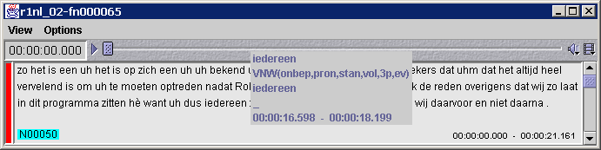
Click and hold down the right mouse button on a word (e.g. iedereen) and a text box pops up displaying all track information available, plus the media timecodes.

2.2 Options Menu

2.2.1 Praat Synch

Before selecting the Praat Synch option (Options menu), you must first start the Praat signal processing program, otherwise an error message appears.

In order to be able to conduct analysis of individual utterances of transcription text, you should also have selected the Audio Player option.

*If you continually use the Praat signal processing program, there will be an accumulation of data objects unless you actively remove the data objects as you finish with them. If you do not remove them, this will quickly result in a problem due to lack of available memory.

3. Search Dialogue Panel

The Search Dialogue Panel gives you considerable flexibility for conducting searches, allowing you to specify several search parameters. Currently searches are conducted throughout the entire Corpus Gesproken Nederlands, however this will be changed in the near future.

During a search the number of “hits” (matches) to your search criterion is shown, as well as a the search progress (see illustration below).

Once a search is completed, the Sub-Corpus folder and Session location is given for each hit. All the hits are displayed and highlighted in yellow in the Search Dialogue Panel within the context of their surrounding utterance text (see illustration below).

Double clicking on a highlighted hit will open the corresponding Session Viewer where the utterance containing the search item is shown (highlighted in blue).

Search Dialogue Panel options
  - Track Selection menu
  - Regular Expression Search
  - Add Criterion button
3.4 Add Query button
3.5 Delete Query button
3.6 Start Search and Close buttons

Enter your search term in this text field box. (e.g. “fietsen”)

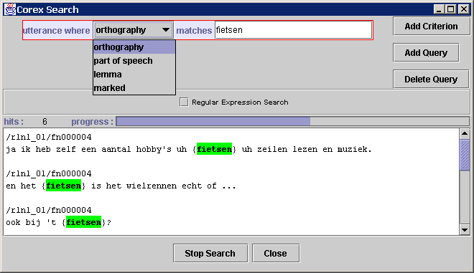

Click here for a Regular Expression Search.
Track Selection menu: Select a track to conduct the search on.
“Hits” are highlighted and their locations are given. Double click on a hit to open the corresponding Session Viewer.

3.1 Track Selection menu

Located next to the coloured text box containing “utterance where” (see illustration on previous page) is the drop-down Track Selection menu labelled "orthography” (orthography is the default track). To search on a track other than orthography, click on the drop-down menu and select part of speech, lemma, or marked word.

Then type in the term(s) you are looking for in the text field box to the right of the blue text “matches. At this point you can either start the search (click the Start Search button) or you can add further criteria to your search by clicking the Add Criterion or Add Query buttons.

If you want to conduct a search for a regular expression pattern, you must select the option (the default search is not set for regular expression searches).

3.2 Regular Expression Search

This option allows you to search for regular expression patterns (using Perl syntax). First enter the term(s) you want to conduct a regular expression search for in the text field box. enable the Regular Expression Search by clicking with the left mouse button on the box immediately to the left of Regular Expression Search text in the Search Dialogue Panel (see illustration on previous page). A check mark appears in the box when the option is enabled.

3.3 Add Criterion

Add Criterion allows you to modify the initial search criterion by adding several search parameters. An important distinction between Add Criteria and Add Query searches is that an Add Criterion search is conducted for matches to your criterion within utterances, whereas an Add Query enables you to conduct searches where matches may extend over more than one utterance.
Click on Add Criterion and the Search Dialogue Panel selection options are modified (see illustration below). Enter the term(s) you are searching for in the text field box and use the Add Criterion options to specify the conditions you want met. Click on Start Search and the hits are displayed for utterances where your search criterion are met
Enter your search term(s) in this text field box

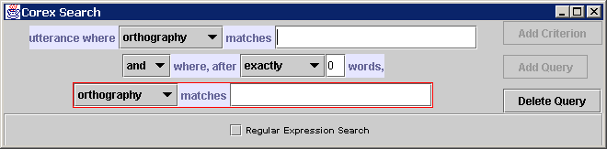
Add Criterion modifications to Search Dialogue Panel

3.4 Add Query

The Add Query option enables you to conduct searches where matching criterion may extend over more than one utterance (Add Criterion searches are within utterances).
Click on Add Query and the Search Dialogue Panel selection options are modified (see illustration below). Enter the term(s) you are searching for in the text field box and use the Add Query options to specify the conditions to be met. Click on Start Search and the hits are displayed for utterances where your search criterion are met

Enter your search term(s) in this text field box
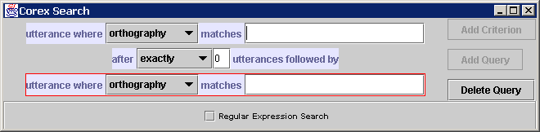
Add Query modifications to Search Dialogue Panel.

3.5 Delete Query

To remove search modifications or return to the initial Search Dialogue Panel options, select one of the sub-queries and then click the Delete Query button. This removes the search parameters added by either Add Criterion or Add Query..

3.6 Start Search and Close buttons

Click the Start Search button to conduct a search of the entire CGN for the term(s) you are looking for. During a search, the Start Search button switches to a Stop Search button that allows you to interrupt a search in progress.

When you are finished with the search, click on the Close button to close the Search Dialogue Panel.

4. Statistics Dialogue Panel

The Statistics Dialogue Panel allows you to count occurrences of a term throughout the CGN. Enter your search term in the text field box and then select one of the four track options from the Track Selection menu: orthography, part of speech, lemma, or marked word (see illustration below).

During a statistics search the number of hits (occurrences) is indicated, as well as progress towards completion of the search.

Once a statistics search is completed, the total number of hits is displayed along with the number of files searched and the time taken to conduct the search.

Statistics Dialogue Panel selection options
4.1 Track Selection menu
  - Start Search and Close buttons
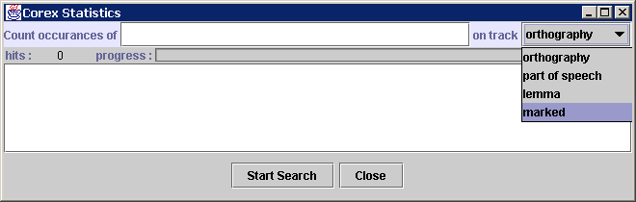
Enter your search term in text field box field.
Track Selection menu: Select the track to conduct the search on.

4.1 Track Selection menu

To the right of the highlighted blue text “Count occurrences of” enter the term you want to be counted. Then, to further define the search, click on the Track Selection menu after the blue text “on track” and choose one track from: orthography, part of speech, lemma, or marked (see illustration above).

4.2 Start Search and Close buttons

Click on Start Search and the entire CGN is searched for the number of occurrences that match your request. During a search, the Start Search button switches to a Stop Search button that allows you to interrupt a search in progress.

When you are finished with the statistics search, click on the Close button to close the Statistics Dialogue Panel.

