Corpus Gesproken Nederlands (COREX)
version 5
Manual
This manual was last updated: 25 Jan 2003
Authors: Paul Kilpatrick, Birgit Hellwig
Introduction
The Corpus Gesproken Nederlands (CGN) is a database of recordings and annotations that contains 10 million spoken Dutch words. The Corex program allows you to listen to, view and analyse the corpus. It supports the following features:
- easy navigation to sub-parts of the corpus, either based on predefined groupings (the sex and age of the speaker, the region in which (s)he grew up, the text type) or based on user-defined groupings (for search purposes or as search results),
- display of synchronised audio and annotation data,
- display, search and statistical analysis of annotation data,
- display and search of metadata descriptions (i.e., information about the kind of data that is contained in the corpus such as information about the speakers).
This manual describes the Corex program commands. It is organised in a sequential manner based on the windows and panels that open up in the program. The following is a list of the Corex windows and panels and their corresponding sections in this manual:
- Corpus Browser Window
- Metadata Search Panel
- Corex Viewer
- TIGERGraph Viewer
- Content Search Panel
- Statistics Panel
Notation Conventions
The following notation conventions are used:
- Menu items, icons and buttons are written in the font MS Sans Serif.
- Screen displays are written in boldface.
- Shortcut keys are written in small caps.
- Information on troubleshooting starts as follows: !
Table of Contents
1 Corpus Browser Window 3
1.1 Meta Descriptions Tree Panel 4
1.1.1 Navigating through the CGN corpus 4
1.1.2 Displaying information 6
1.1.3 Selecting parts of the corpus for purposes of analysis 8
1.2 Bookmarks Panel 10
1.3 Info/Content Panel 11
1.4 Description Panel 12
1.5 Browser Action Panel 13
2 Metadata Search Panel 14
2.1 Specify the search options 15
2.1.1 Select the category to be searched 15
2.1.2 Enter the search term 18
2.1.3 Add or delete a search query 18
2.2 Initiate and stop the search 19
2.3 Display the search results 19
2.4 Save the search results 19
2.5 Exit the Metadata Search panel 20
3 Corex Viewer 21
3.1 View Menu 22
3.1.1 Audio Player 22
3.1.2 Wave Panel 23
3.1.3 Print to file 24
3.1.4 Time Synch 24
3.1.5 Visible Tracks 25
3.2 Options Menu 25
3.2.1 Praat Synch 25
4 TIGERGraph Viewer 27
5 Content Search Panel 29
5.1 Track Selection Menu and Text Field Box 31
5.2 Regular Expression Search 33
5.3 Case-Sensitive Search 35
5.4 Add new constraint button 35
5.5 Delete last constraint button 36
5.6 Show dependencies button 37
5.7 Start/Stop Search button 37
5.8 Save Results As … button 37
5.9 Open Result Set … button 37
5.10 Save Results As Corpus … button 38
5.11 Close button 38
6 Statistics Panel 39
Appendix A 41

User’s Guide

Corpus Browser Window
Starting the Corex program opens up the window IMDI-BCBrowser for Corpus Gesproken Nederlands (referred to in this manual as the “Corpus Browser” window).
In the Corpus Browser window you can view and access the directory of the Corpus Gesproken Nederlands (CGN): you can read information about the kind of data that is contained in the corpus, you can access the annotation and audio files, and you can initiate searches and do statistical counts.
The Corpus Browser window contains the following five panels:
  - Meta Descriptions Tree panel
  - Bookmarks panel
  - Info/Content panel
  - Description panel
  - Browser Action panel

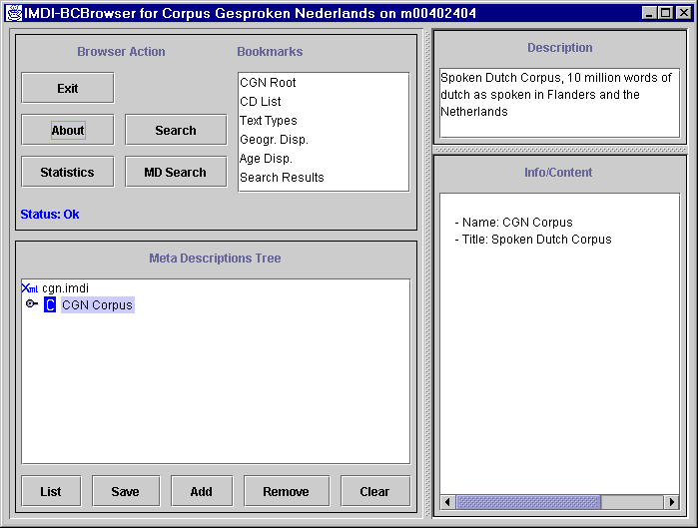
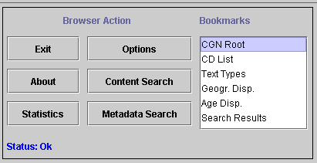
Info/Content
Meta Descriptions Tree
Description
Browser Action
Bookmarks

Meta Descriptions Tree Panel
The Meta Descriptions Tree panel allows you to navigate through the predefined structure of the Corpus Gesproken Nederlands (CGN). It thereby gives you access to the audio, the annotation and the metadata description contained in the corpus. In addition, there are five buttons at the bottom of the panel that allow you to select parts of the CGN corpus for purposes of analysis.
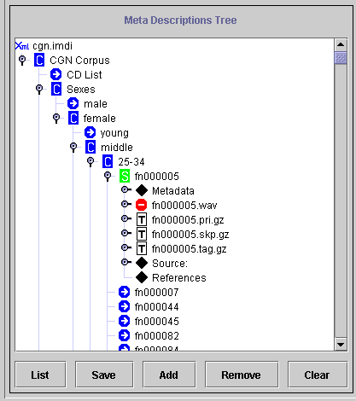
Session nodes
Corpus nodes
Session data:
annotation and audio data
metadata descriptions
Buttons for selecting parts of the corpus
CGN corpus

Navigating through the CGN corpus
The CGN corpus is displayed when the Corpus Browser window initially opens up. Double-click on the CGN corpus icon to display its corpus nodes; double-click on any corpus node to open it and to display the next level in the hierarchy.
! Note: The Meta Descriptions Tree distinguishes between open and closed corpus and session nodes. These are represented through different icons:
Icon of an open corpus/session.Icon of a closed corpus/session.

Most of the program commands do not work when the node is closed. Therefore, if any of the commands do not seem to work, please make sure that the node is open. Double-click on its icon to open it.
! Note: Because of the large amount of data that is loaded, it may take some time until Corex responds to the ‘open’ command.
The CGN corpus branches into five sub-corpora. All five sub-corpora contain the same kind of data, but they group it according to different parameters:
- CD List: the CGN corpus as it is grouped according to the audio CDs that are supplied with Corex.
- Ages: the CGN corpus as it is grouped according to the age and sex of the speaker(s).
- Sexes: the CGN corpus as it is grouped according to the sex and age of the speaker(s).
- Regions: the CGN corpus as it is grouped according to the native region of the speaker(s) (i.e. his/her place of residence between the ages 4 and 16).
- Text types: the CGN corpus as it is grouped according to the discourse genre.
The lowest level in the CGN directory is the session. Each session corresponds to a single piece of data. E.g., the session labelled “fn000001” contains a spontaneous commentary of a middle-aged male speaker from the region Gelders Rivierenland. Furthermore, each session is linked to all relevant corpus nodes in the directory. E.g., the session labelled “fn000001” is linked to the corpus node middle-aged male speakers (Sexes/ male/ middle/ 25-34), the node Gelders Rivierenland (Regions/ The Netherlands/ transitional region/ Gelders Rivierenland) and the node spontaneous commentary (Text types/ monologue/ public/ broadcast/ unscripted/ spontaneous commentary).
Each session node contains the following kind of information:
- metadata descriptions, i.e., information about the actual audio and annotation data (see sections 1.3 and 1.4),
- links to a *.wav file (i.e., an audio file),
- links to a number of annotation files (*.pri, *.skp, *.tag, *.syn, *.bpt, *.lxk).
Double-click on any session node to open a viewer panel (the Corex Viewer), which displays the session’s annotations (see section 3). Each session has a corresponding audio file. In order to use the Corex Audio Player or Wave Panel features, you need the CD that contains the relevant audio file (see sections 3.1.1 and 3.1.2).
! Note: You can only access the Corex Viewer and the Audio Player and Wave Panel through double-clicking on the session icon:
Clicking on any of the annotation files will not start the Corex Viewer. Nor will clicking on the audio file start the Audio Player.
! Note: For some sessions the data files are not available yet. Available and non-available files are represented through different icons:
Icon of a non-available file.Icon of an available file.

Some files are not available because they exist in compressed form only. The Corex Viewer and the Audio Player nevertheless work normally (see section 3). Note that a missing annotation file does not have any consequences for the analysis: the Corex program will include this session whenever it performs searches or statistical counts.

Displaying information
A left mouse click on any node in the Meta Descriptions Tree panel will highlight this node; and a right mouse click on any open highlighted node will display a drop-down menu, offering you a number of different options.
! Note: Not all options are available for all nodes.
! Note: For some nodes, one of the options is marked with the symbol #. In this case, the corresponding option will start automatically whenever you double-click on the open node.
The following options are available:
Add to basket Adds the node to the list of nodes to be analysed (see section 1.1.3).
Add to Bookmarks Adds the node to the Bookmarks panel.
Clone Node Opens a second Corpus Browser window that displays only the corresponding node.
COREX viewer Opens the Corex Viewer, which displays the session’s annotations and gives you access to the audio data (see section 3). This is the default setting for any session - i.e. a double-click on the session node will automatically open the Corex Viewer.
IMDI-BCEditor Opens the corresponding metadata file in the IMDI Editor (see the separate manual “IMDI Editor” for details: http://www.mpi.nl/tools/imdieditor.html).
List Sessions Lists all sessions contained under this node in the Info/Content panel.
MetaData Search Opens the IMDI Metadata Search panel (see section 2).
Remove Removes the node from the Meta Descriptions Tree panel.
Remove from basket Removes the node from the list of nodes to be analysed (see section 1.1.3).
Save File Content Downloads the file in a non-compressed format.
Session Count Displays the number of sessions contained under this node in the Info/Content panel.
Show Displays the file content in the Info/Content panel. This is the default setting for any annotation file (*.pri, *.skp, *.tag, *.syn, *.bpt, *.lxk) - i.e. a double-click on such a file will automatically display its content.
Show Content-Type Displays the file format in the Description panel.
Show Description Displays the file description in the Description panel.
Show File Content Displays the XML file of the node in the Info/Content panel.
Show format Displays the file format in the Info/Content panel.
Show LR’s Displays the directory information for all files contained under this node in the Info/Content panel.
Show URL Displays the directory information for the file in the Description panel.
Show SearchService Displays the name and directory information of the file that contains the metadata information (i.e., the file cgn.dbf) in the Info/Content panel.
Tiger Opens the TIGERGraph Viewer (see section 4).

All information is either displayed in the Info/Content panel (see section 1.3) or in the Description panel (see section 1.4). The following illustration is an example of how selected information is displayed in the Info/Content panel:

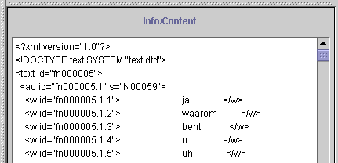
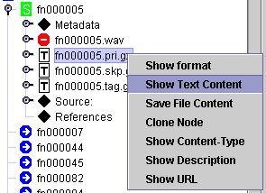
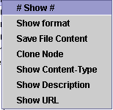
Information displayed in the Info/Content panel
Accessed data file
Selected option

Selecting parts of the corpus for purposes of analysis
The Corex program allows you to do metadata and content searches as well as statistical counts of the corpus (see sections 2, 5 and 6). By default, the analysis is done throughout the whole corpus. However, it is possible to limit the analysis to a part of the corpus: to one (or several) corpus and/or session nodes. The five buttons at the bottom of the Meta Descriptions Tree panel are needed for the selection process.
To select a corpus or session node, do the following:
- Open the node through double-clicking on it.
- Highlight the node through clicking on it with the left mouse button.
- Either click the Add button at the bottom of the Meta Descriptions Tree panel.
Or click with the right mouse button on the highlighted item, and select Add to basket from the drop-down menu.
The icon of any selected node will change its colour to grey, e.g.:
Non-selected node.Selected node.

Furthermore, once an item is selected, the List button will be highlighted in red colour.
- Repeat this process to add other nodes to your selection.
! Note: You can only select a node that is open. Double-click on it to open it.
! Note: It is possible to select several different nodes, e.g. the nodes (a) ‘male’ and (b) ‘The Netherlands’. The analysis will then be done over all sessions contained under the node ‘male’ (regardless of region) and all sessions contained under the node ‘The Netherlands’ (regardless of sex). This option does not allow you to limit the search to, e.g., all male speakers that grew up in the Netherlands. To limit your search in such a way, make use of the metadata search options (see section 2).
! Note: When you limit your search to, e.g., the node ‘male’, it is not necessarily the case that the search tool will only find those items that are actually spoken by a male speaker. The node ‘male’ also contains sessions with dialogues between male and female speakers. Searching such sessions may thus include data from female speakers. To limit your search to, e.g., male speakers, make use of the metadata search options (see section 2).
Click the List button to view a list of all selected nodes, e.g.:
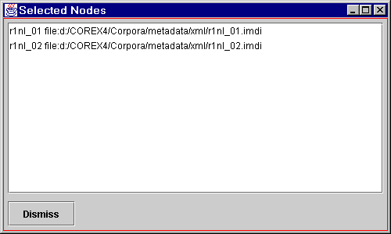

Click the Dismiss button to return to the Meta Descriptions Tree panel.

You can remove all selected nodes from this list by clicking the Clear button at the bottom of the Meta Descriptions Tree panel.
To remove a specific node from the list, do the following:
- In the Meta Descriptions Tree panel, highlight the node through clicking on it with the left mouse button.
- Either click the Remove button at the bottom of the panel.
Or click with the right mouse button on the highlighted item, and select Remove from basket from the drop-down menu.
- Repeat this process to remove other nodes from your selection.
You can save the selected list for future uses. Click the Save button. The following message informs you that your list has been saved:
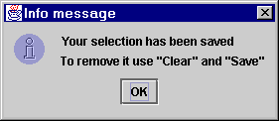

! Note: Once you have saved a selected list, you can only remove it by first clicking the Clear button (to remove all selected nodes) and then the Save button (to save an empty list).
When you are satisfied with your selection, turn to the Browser Action panel in order to initiate searches or statistical counts (see section 1.5).

Bookmarks Panel
The Bookmarks panel of the Corpus Browser window displays shortcuts to various nodes in the corpus. Having a bookmark allows you to immediately access such a node, without being obliged to first navigate through the entire corpus. By default, the following bookmarks are displayed:
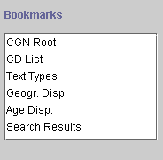

- CGN Root: the whole CGN corpus.
- CD List: the CGN corpus as it is grouped according to the audio CDs that are supplied with Corex.
- Text Types: the CGN corpus as it is grouped according to the discourse genre.
- Geographical Dispersion: the CGN corpus as it is grouped according to the native region of the speaker(s) (i.e. his/her place of residence between the ages 4 and 16).
- Age Dispersion: the CGN corpus as it is grouped according to the sex and age of the speaker(s).
- Search Results: the saved results of your searches (see sections 2 and 5).
Double-click on any of these items in the Bookmarks panel to open the corresponding node in the Meta Descriptions Tree panel.
In addition to the predefined bookmarks, you can create your own bookmarks. Do the following:
- In the Meta Descriptions Tree panel, open the relevant corpus or session node through double-clicking on it.
- Highlight the open node through clicking on it with the left mouse button.
- Right-click on the highlighted node and select Add to Bookmarks from the drop-down menu.
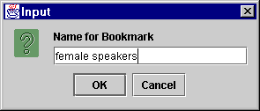
The following dialogue box appears:

- Type in a name for the new bookmark.
The new bookmark is added to the Bookmarks panel.
These bookmarks remain available every time you restart Corex. To remove a bookmark, do the following:
- In the Bookmarks panel, click on the bookmark that you want to remove.
- Right-click on that bookmark and select Delete Bookmark from the drop-down menu.
The bookmark is deleted without further warning.
! Note: You can only delete those bookmarks that were created by yourself, but never the ones that are predefined by Corex.

Info/Content Panel
The Info/Content panel displays information about corpus nodes, session nodes and files. To read the information, click on the corresponding icon in the Meta Descriptions Tree panel.
! Note: The information is only displayed when the corpus or session node is open. Double-click on it to open it.
In the case of corpus and session nodes, information about the name of the node, the title, and (in the case of sessions) the recording date is displayed, e.g.:
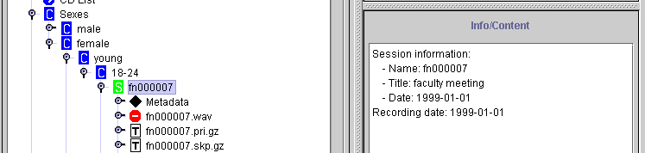
Information about session “fn000007”

In the case of a Metadata node, the following kind of information is displayed:
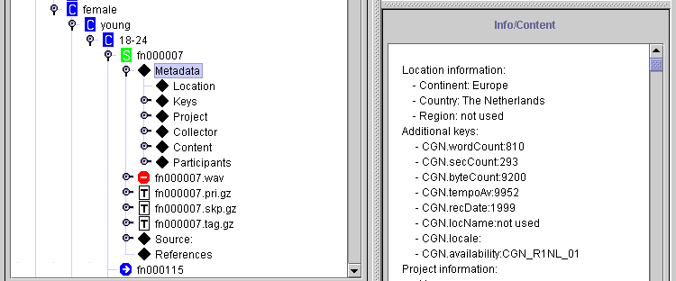
Metadata descriptions

- Location: information about the place where the data was collected.
- Keys: information about the size of files, and about the name of the session CD on which the corresponding audio file is located.
- Project: information about the project within which the data was collected.
- Collector: information about the person who collected the data.
- Content: information about the content: the task, the genre, etc.
- Participants: information about the participants.
- Source: information about the source.
- References: information about additional references relevant to the content of the session.
The Info/Content panel can optionally display additional information such as a list of all the sessions contained under a node, a count of all the sessions contained there, the content of XML files, the format of file(s), the directory information of file(s) and the directory information of the file containing the metadata descriptions. To view this information, do the following:
- In the Meta Descriptions Tree panel, click on the node or file whose information you want to view.
- Right-click on the highlighted node or file.
- Select an option from the drop-down menu (see section 1.1.2 for the available options). The relevant content is displayed in the Info/Content panel.

Description Panel
The Description panel displays a brief description of corpus nodes, session nodes and files. To read the description, click on the corresponding icon in the Meta Descriptions Tree panel, e.g.:
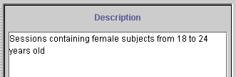
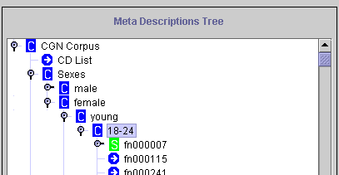
Description of the node “18-24”

! Note: The information is only displayed when the corpus or session node is open. Double-click on it to open it.

Browser Action Panel
With the Browser Action panel you can initiate searches and statistical counts of the CGN corpus, and you can exit the Corex program.
It contains the following six buttons:
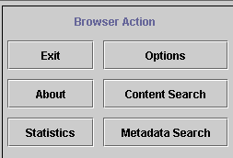

- Exit: click this button to exit the Corex program.
! Note: When you open a second Corpus Browser window (either through the option Clone Node (see section 1.1.2), or through double-clicking on search results in the Metadata Search panel (see section 2.3)), the Exit button of the second window turns into a Close button. This allows you to close the second window without exiting the Corex program.
- About: click this button to view the copyright and version information.
- Statistics: click this button to conduct statistical counts (see section 6).
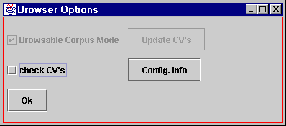
- Options: click this button to set options. The following two options are available:

- Check CV’s: checks the values in the metadata description files against the allowed values. You can ignore this option.
- Config. Info: displays information about the configuration, which you might need when reporting a bug to the developers.
- Content Search: click this button to conduct searches on the content of the annotation files (see section 5).
- Metadata Search: click this button to conduct searches on the metadata descriptions (see section 2).

Metadata Search Panel
The Metadata Search panel is accessed either through the button Metadata Search in the Browser Action panel of the Corpus Browser window (see section 1.5) or through right-clicking on an open highlighted corpus node in the Meta Descriptions Tree panel and then selecting MetaData Search from the drop-down menu (see section 1.1.2).
The Metadata Search panel allows you to conduct searches for metadata descriptions throughout the entire Corpus Gesproken Nederlands (the default setting) or throughout selected parts of the corpus (see section 1.1.3).
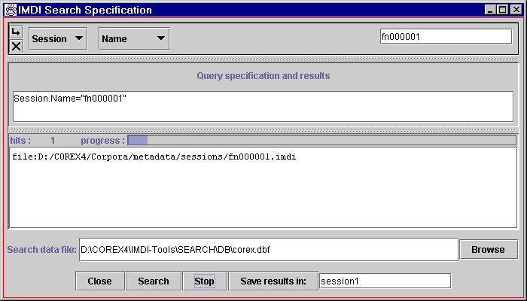
Search results
The file containing all metadata information
Use these buttons to close the search window, to start the search, to stop the search and to save the results.
You can specify a name for the file in which the results should be saved.
Information on number of ‘hits’ and search progress
Specify the search options here.

The following options are available:
  - Specify the search options.
  - Initiate and stop the search.
  - Display the search results.
  - Save the search results.
  - Exit the Metadata Search panel.

Specify the search options
The search options are specified in the topmost part of the Metadata Search panel, e.g.:
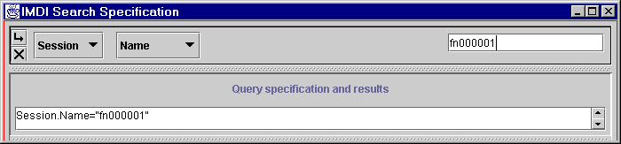
Enter the search term here.
Press Enter to commit the search term.
The category in which the search is conducted: Session Name.
Use this button to add a query.
Use this button to delete the query.

The following search options are available:
    - Select the category to be searched.
    - Enter the search term.
    - Add or delete a search query.

Select the category to be searched
The categories to be searched are predefined by Corex and are displayed in form of drop-down menus (see the separate CGN Documentation for an explanation of all the different categories).
The default categories, which are displayed every time you access the Metadata Search panel, are Session and Name. These two options allow you to search for the name of a session.
You can select other categories by clicking on the drop-down menus:
- The first category is always Session.
- The second category is chosen from the following list: Name, Date, Location, Key, Participant, or Content.
- Depending on your choice for the second category, further drop-down menus will appear to narrow down the category.
! Note: Whenever you point with the mouse at a category, a blue box (the so-called “tool-tip”) will appear and explain the meaning of that category, e.g.:
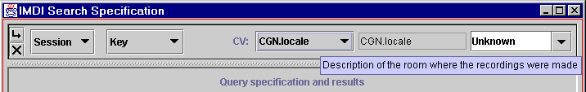
Explanation for the keyword CGN.locale

! Note: If too many categories and drop-down menus are added, the Metadata Search panel cannot display them all. To increase its size, click on the full screen icon (in the top right corner of the panel):
In the remainder of this section, some examples of metadata searches are given.
(1) In the following illustration, Location was chosen as the second category. A third drop-down menu appeared sub-dividing the category Location into Continent, Country, and Region. When Country was chosen, a fourth drop-down menu appeared displaying the names of all countries.
The selected category is automatically added to the box Query specification and results.
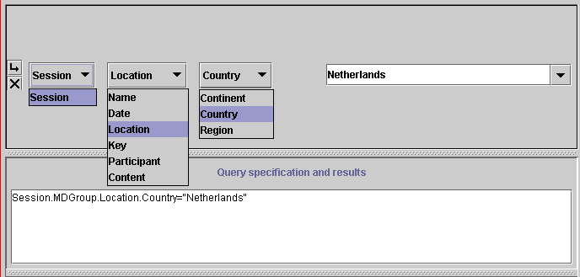
Further sub-divisions within the specified category
First and second category
The selected category is automatically added to this box.

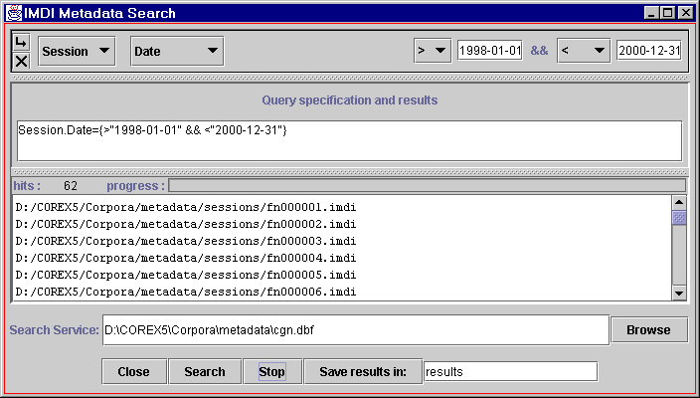
(2) In another example, Date was chosen as the second category (i.e., the date of the recording), e.g.:
recorded after 1.1.1998
recorded before 31.12.2000
and

In this case, further drop-down menus allow you to specify the exact time period, e.g.:
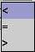
search for a date before the specified date
search for the exact date
search for a date after the specified date

For example, the specification “> 1998-01-01 && < 2000-12-31” in the illustration above reads as “after 1.1.1998 and before 31.12.2000.”
(3) The last example illustrates a search for keywords. Whenever you select the category Key, a drop-down menu with the available keywords will appear. Select one of the keywords, and another drop-down menu with the available values will appear. For example, you can search in the category Participant for all those sessions that contain the value lang02 (i.e., Language No. 2, see the separate CGN Documentation for an explanation of the different values) under the keyword CGN.homeLang (i.e., language spoken at home):
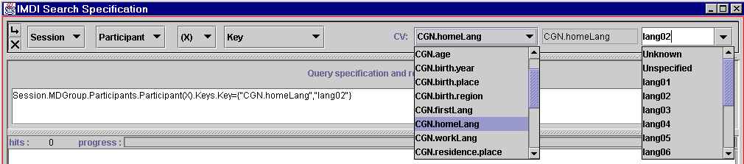
Available keywords for the category participant
Available values for the key CGN.homeLang

Enter the search term
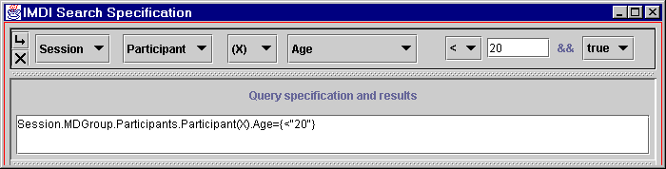
After you have selected the categories to be searched, the search term can be entered into the box in the top right corner of the Metadata Search panel, e.g.:
The search term

Some search terms have to be entered manually, others can be chosen from a drop-down menu.
! Note: See the separate CGN Documentation for an explanation of how metadata descriptions are coded in the CGN Corpus.
! Note: If the search term is entered manually, you need to press the key Enter before you can start the search.
! Note: You can also type the search term directly in the box Query specification and results. Type the term between the two quotation marks following the category specification, e.g.: =“20”.

Add or delete a search query
You can add and delete queries as follows:
use this button to add a query
use this button to delete the query

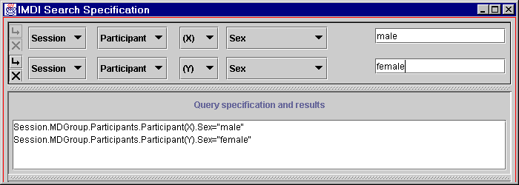
When two (or more) queries are specified, metadata search will search for all sessions that contain query 1 and query 2 (and all subsequent queries). For example, in the following illustration, all sessions will be found that contain (1) a male participant X and (2) a female participant Y.

! Note: Variables such as X and Y are only of relevance if you specify more than one query. In this case, they allow you to specify that the participant of query 1 (X) should either be different from the participant of query 2 (Y) or that (s)he should be identical to the participant of query 2 (X). Please ignore these variables if you specify one query only.

Initiate and stop the search
Click the Search button at the bottom of the Metadata Search panel to start the search. During the search the number of “hits” (matches) to your search criterion is shown, as well as the progress towards the completion of the search.
! Note: Because of the large amount of data that is searched, it may take some time before the search is completed.
! Note: The file that contains all metadata descriptions is specified following the coloured text box Search Service:. It is already configured correctly: please do not change its location or name.
Once the search process is started, you can use the Stop button to stop the search again.

Display the search results
Once the search process is started, the box Query specification and results in the Metadata Search panel starts displaying the session node location for each hit.
Double-click on a session node location to open a second Corpus Browser window that contains the selected session, its metadata descriptions and its audio and annotation files (see section 1).

Save the search results
You can save all sessions that contain the search results as a corpus node. This node is displayed in the Corpus Browser window. Do the following:
- In the Metadata Search panel, specify a name in the text box following the button Save results in:.
- Click the button Save results in:. The results are saved under the specified name.
You can access the results through the Corpus Browser window (see section 1): go to the Bookmarks panel and double-click on Search Results. The Meta Descriptions Tree panel will display the new corpus under the node Results, e.g.:
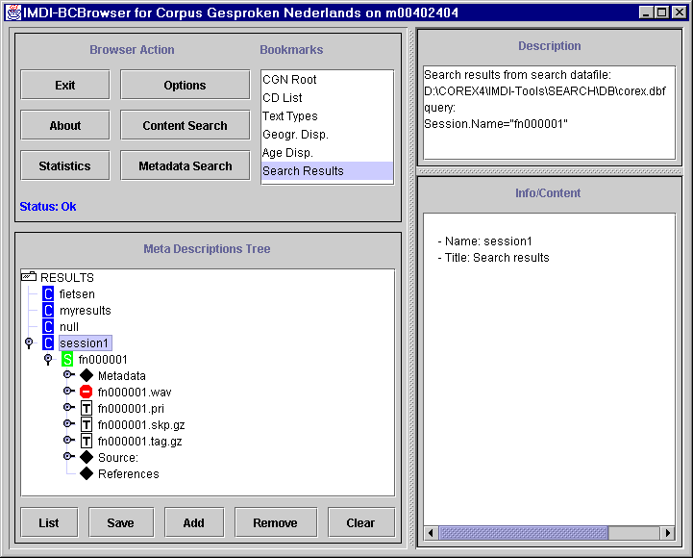
(Search) Results node
The results of the metadata search

This new corpus node is treated like any other corpus node: it contains sessions (those sessions where the search term was found), and the sessions contain metadata descriptions and give access to the Corex Viewer, the TIGERGraph Viewer, the Audio Player and the Wave Panel.
! Note: You can do a content search on this newly created corpus (see section 5). In this case, if the newly created corpus is based on the category Participant (e.g., a corpus of all sessions that contain utterances by male speakers below 30 years of age; see section 2.1.1), the content search on this corpus will only search the utterances of the corresponding participant category (i.e., male speakers below 30 years of age) - if the corpus contains sessions with dialogues between, e.g., male and female speakers, the utterances of the female speakers will be ignored.
You can remove the saved corpus node again. Go to this node in the Meta Descriptions Tree panel. Click on it to highlight it. Then right-click on the highlighted node and select Remove from the drop-down menu.
! Note: After selecting Remove, the icon of the removed node remains visible although it cannot be accessed anymore. The icon will be removed after exiting the node Results.

Exit the Metadata Search panel
Click the Close button at the bottom of the Metadata Search panel to exit the panel.

Corex Viewer
The Corex Viewer is accessed through double-clicking on any session node in the Meta Descriptions Tree panel of the Corpus Browser window (see section 1.1). It is a view panel that displays all annotated utterances of the corresponding session, e.g.:
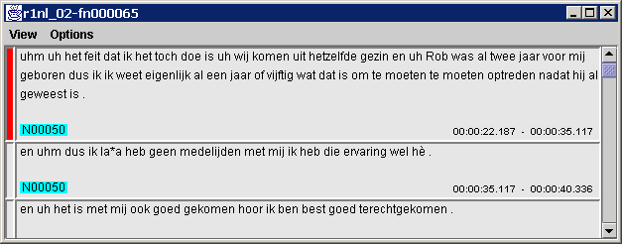
Label identifying either the speaker or the transcriber
Red bar indicating the selected utterance
Timecode for the beginning and the end of the utterance
One utterance or annotation unit

Use the scroll bar to the right of the Corex Viewer to navigate through the document.
The Corex Viewer is organised around annotation units. Each unit corresponds to one utterance, and contains the following information: a timecode marking the beginning and the end of the utterance and an alphanumeric label identifying the speaker (e.g. “N00050” in the above illustration). In some cases the word comment appears instead of the speaker identification number: this indicates that the utterance is a comment made by the transcriber.
A vertical red bar appearing to the left of a unit indicates it is the selected unit. Occasionally two units will have the red bars beside them (this happens when neighbouring units have the same media timecodes).
This section of the manual describes the options available in the Corex Viewer:
  - View menu
    - Audio Player
    - Wave Panel
    - Print to file
    - Time Synch
    - Visible Tracks
  - Options menu
    - Praat Synch

View Menu
The View menu contains five options: Audio Player, Wave Panel, Print to file, Time Synch and Visible Tracks.

Audio Player
When you select the Audio Player option, you are prompted to insert the corresponding CD into the CD drive, e.g.:
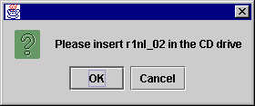

At the prompt, insert the CD and click the OK button. The Corex Viewer is slightly modified: there is now a new bar that contains a media time counter, a scroll bar with a play/stop button, a speaker icon, and a media properties icon.
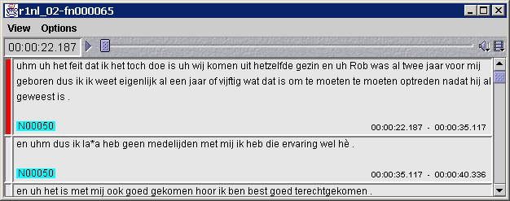
Media properties icon
Play/stop button
Speaker icon
Scroll bar
Media time counter: hours:minutes:seconds.hundredths of seconds

All movements of the Audio Player are synchronised with the Corex Viewer (and the Wave Panel), so that any adjustments to the utterance location made in one will also be made in the other.
- The media time counter displays the media time location in the annotated text. Double-click on the media time counter box and a Go To window opens up allowing you to enter a new media time. Both the Corex Viewer and the Audio Player adjust their locations according to the new time you specify.
- Use the scroll bar to change the location.
- Click on the play button to begin the Audio Player. Once it commences, the play button changes to a stop button (two parallel vertical bars). As the file is played, the Corex Viewer displays the corresponding annotations.
- The speaker icon is used to adjust the volume level or to mute the sound altogether. To adjust the volume, click on the icon with the right mouse button and a scrollable volume bar will appear. To mute the sound, click on the speaker icon with the left mouse button and a line will appear through the icon (indicating the sound has been muted).
! Note: If you are having an audio problem, first make sure your speakers are turned on.
- For technical information, click on the Media Properties icon to open the Media Properties window. This window contains three sections: General, Audio, and Plug-in Settings. To view the contents of a specific section, click on the appropriate tab heading and the information will be displayed.

Wave Panel
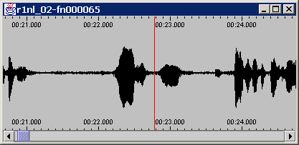
When you select the Wave Panel option, a window opens up showing the corresponding waveform. The Wave Panel is synchronised with the Corex Viewer and the Audio Player, so that any adjustments to the utterance location made in one will also be made in the other.
Media time is indicated above and below the waveform.
Location indicator bar
Scroll bar

- Identical media time indicators are located above and below the waveform.
- Use the scroll bar to change the location in the waveform (and in the Corex Viewer and the Audio Player).
- A vertical red line moves along the waveform, marking the current media time. You can click on any part of the waveform to move to that location.
- You can change the resolution of the waveform using the Arrow keys on the keyboard. Use the Left Arrow to zoom in, and the Right Arrow to zoom out.

Print to file
Select this option to save the content of the file. A dialogue box opens up that prompts you to select the directory in which to save the file. Please save the file as an *.html file, e.g.:
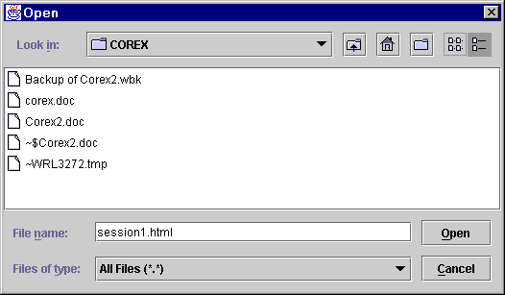
Save the file as an *.html file.

You can open the *.html file in, e.g., Netscape and print it from there. The file will look similar to the illustration below.
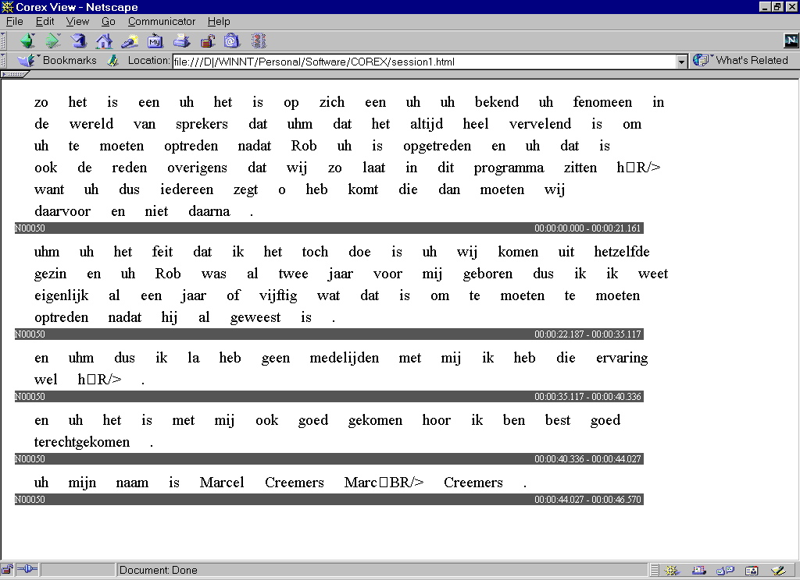

! Note: The Print to file option will only print the annotation units that are currently visible on your screen. It will not print the entire file.

Time Synch
By default, the Corex Viewer, the Audio Player and the Wave Panel are synchronised on the level of the annotation unit. However, by selecting the option Word under Time Synch you can get a finer level of synchronisation.
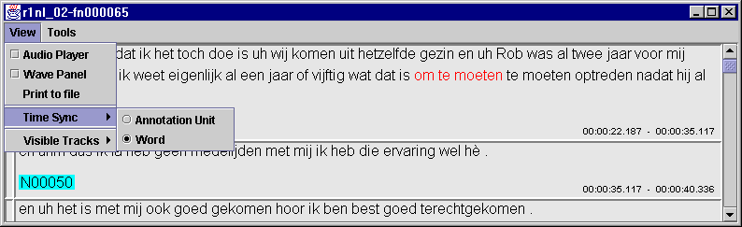
Synchronization at the word level

! Note: Strictly speaking, the synchronisation does not take place on the word level, but at the smallest available unit that is provided by the CGN (e.g., “om te moeten” in the illustration above).

Visible Tracks
Under the Visible Tracks option you can select the tracks (or tiers) to be displayed in the Corex Viewer. There are up to five different options or tracks for viewing the annotated text: Orthography, Part Of Speech, Lemma, Marked word, or Phonetics. Click on any track that you want to be displayed.
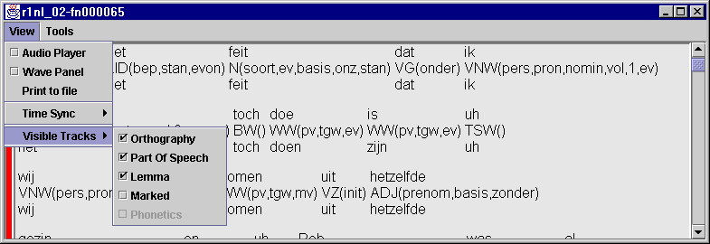
You can click on any or all of these tracks. The Corex Viewer displays all selected tracks.

It is also possible to view all tracks for individual words in the utterance. To do so, point to the word with the mouse and click on it with the right mouse button. The tracks for the selected word are displayed for as long as you hold down the right mouse button, e.g.:
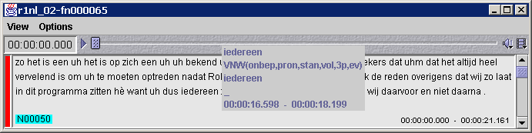
Click and hold down the right mouse button on a word (e.g. “iedereen”) and a text box pops up displaying all track information available, plus the media timecodes.

Options Menu

Praat Synch
You can use the Praat signal-processing program to analyse individual utterances. But before selecting the Praat Synch option, you must first start the Praat program, otherwise an error message appears. And you should also have selected the Audio Player option.
! Note: If you continually use the Praat signal-processing program, there will be an accumulation of data objects unless you actively remove the data objects as you finish with them. If you do not remove them, this will quickly result in a problem due to lack of available memory.

TIGERGraph Viewer
The TIGERGraph Viewer is accessed through the Meta Descriptions Tree panel of the Corpus Browser window: double-click on a session node to open it, click with the left mouse button on the open node to highlight it, click with the right mouse button on the highlighted node to open the drop-down menu, then select Tiger from the drop-down menu (see section 1.1.2). Note that this option is not available for all sessions.
The TIGERGraph Viewer is a view panel that displays syntactical information, e.g.:
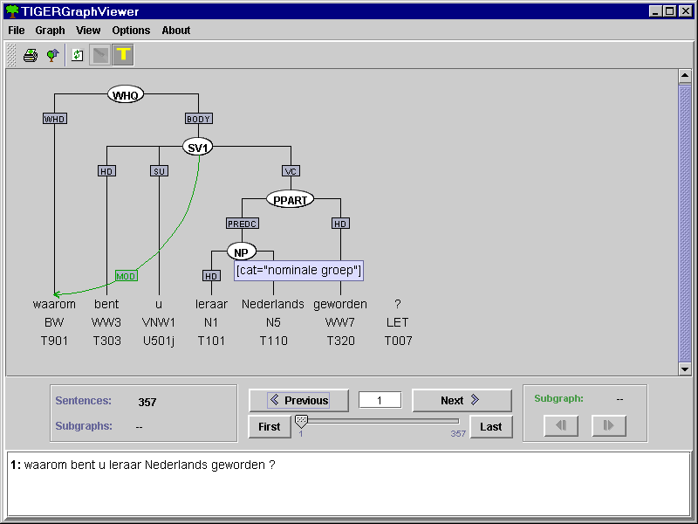
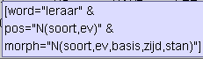
Displaying the syntactical structure of a sentence
Buttons for navigating through the session file
Click here to hide a part of the graph

Tool-tip (displaying information about a node or word)

The analysed sentence

The TIGERGraph Viewer supports the following options:
- Displaying the syntactical structure of each sentence in the form of a tree structure.
To view information about any of the nodes or words, point with the mouse to it. A blue box (the so-called “tool-tip”) will display the corresponding information.
To hide any part of the tree structure, click with the middle mouse button on a syntactic node. The corresponding structure will be hidden.
- Navigating through the session file by means of the following options:
- Press Previous / Next to move to the previous / next sentence.
- Press First / Last to move to the first / last sentence.
- Enter the sentence number into the box between Previous and Last and press Enter to jump to the corresponding sentence.
- Click on the scrollbar to jump to a sentence.
- Printing the tree structure of the displayed sentence. Make use of the menu item Graph / Print.
- Changing the colour and display options of the TIGERGraph Viewer. Make use of the menu items Options / Color Options and Options / Display Options.

For details, please see the separate manual for the “TIGERSearch” tool (a copy of the manual is on your distribution CD-ROM; you can also download the manual from http://www.ims.uni-stuttgart.de/projekte/TIGER/TIGERSearch/manuals.html). Note that Corex only implements the TIGERGraph Viewer of the “TIGERSearch” tool (i.e., it only supports the functionality described in chapter 4 “Viewing the matches” of the “TIGERSearch” manual).

Content Search Panel
The Content Search panel is accessed through the button Content Search in the Browser Action panel of the Corpus Browser window (see section 1.5). The first time that you access the Content Search panel, the Indexed search dialog window appears.
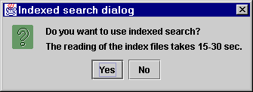
In the dialog window, click Yes if you want to use an indexed search, otherwise click No.
An indexed search is much quicker than a non-indexed search. However, the reading of the index files takes up a lot of memory. It is therefore recommended to use this option only if your computer has at least 128 MB of memory available.
The reading of the index files is only done once per session (i.e., the index files remain available until you exit the Corpus Browser window).

The Content Search panel gives you considerable flexibility for conducting searches, allowing you to specify several search parameters. Searches can be conducted throughout the entire Corpus Gesproken Nederlands (the default setting) or throughout selected parts of the corpus (see section 1.1.3).
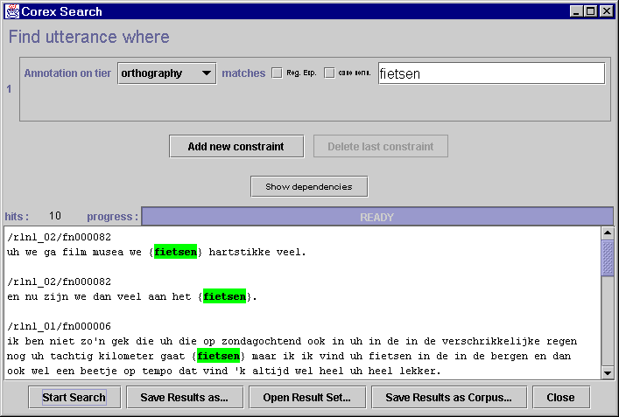
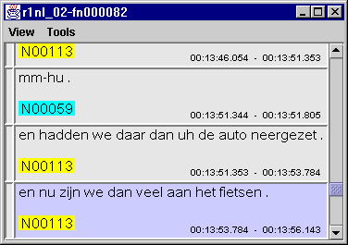
Track Selection menu: select a track to conduct the search on.
Enter your search term into the text field box (e.g. “fietsen”).
Search options.
Hits are highlighted and their locations are given. Double-click on a hit to open the corresponding Corex Viewer, e.g.:

During a search the number of “hits” (matches) to your search criterion is shown, as well as the progress towards the completion of the search.
Once a search is completed, the session node location is given for each hit. All the hits are displayed and highlighted in green colour in the Content Search panel.
! Note: Because of the large amount of data that is searched, it may take some time before the search is completed.
Double-click on a hit highlighted in green colour to open the corresponding Corex Viewer where the utterance containing the search item is shown (highlighted in blue).

The following options are available:
  - Track Selection Menu and Text Field Box
  - Regular Expression Search
  - Case-Sensitive Search
  - Add new constraint button
  - Delete last constraint button
  - Show dependencies button
  - Start/Stop Search button
  - Save Results As … button
  - Open Result Set … button
  - Save Results As Corpus… button
  - Close button

Track Selection Menu and Text Field Box
Located next to Annotation on tier is the drop-down Track Selection menu labelled orthography (the default track or tier). To search on a track other than orthography, click on the drop-down menu and select marked word, part of speech, lemma, or phonetics. Then type in the term(s) you are looking for in the text field box, e.g.:
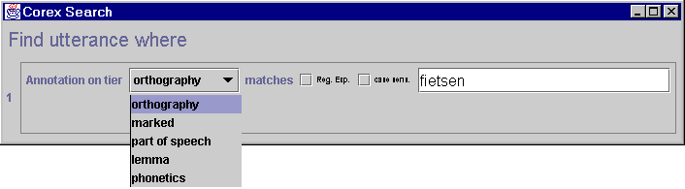
Selected track: orthography

Enter the search term here.

If you have selected either the track part of speech or the track marked word, the text field box changes to a drop-down menu. Select one of the listed items (see the separate CGN Documentation for details of the available categories), e.g.:
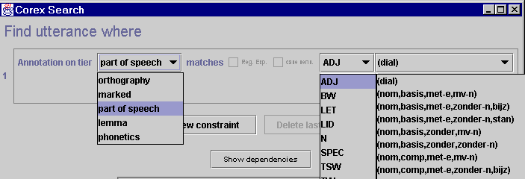
Selected track: part of speech
Available options for the track part of speech
Available options for the category ADJ
Selected category: ADJ

! Note: You can use an asterisk (i.e., a wild card that matches any search term) instead of one of the elements specified in the drop-down menu. Do the following:
- Select a category, and click with the right mouse button into the drop-down menu. The drop-down menu changes into a text box.
- Click with the left mouse button into the text box.
- Press the key Delete. The last element is replaced with an asterisk.
- Repeat steps (2) and (3) to replace other elements.
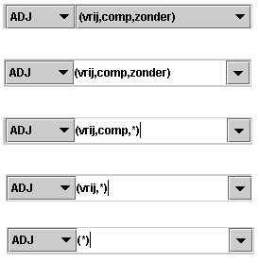
Step 1:

Step 2:

Step 3:

Step 4:

If you have selected the track phonetics, type in the phonetic characters using the SAMPA (Speech Assessment Methods Phonetic Alphabet) keyboard (see the separate CGN Documentation for details). For example, the SAMPA symbol @ matches the phonetic symbol schwa. A search for “h@t” on the track phonetics would thus find all instances of “het”, e.g.:
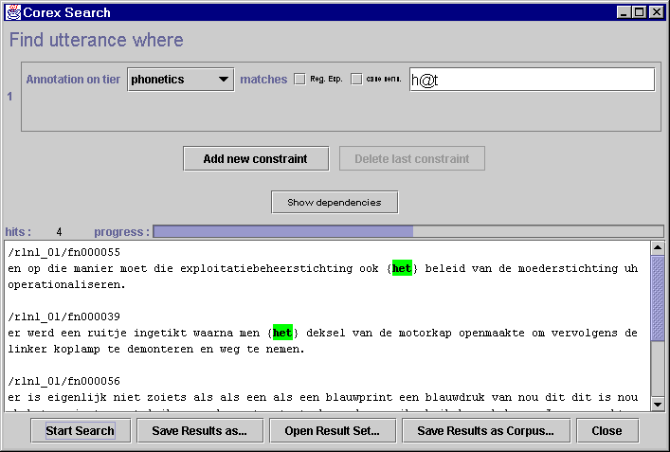
Search term
Hits
Track: phonetics

Regular Expression Search
This option allows you to search for regular expression patterns. A regular expression search makes use of variables (using Perl syntax), e.g.:
. matches an arbitrary character
+ matches the preceding pattern element one or more times
? matches the previous character zero or one times
* matches the previous character zero or more times

The following example illustrates a regular expression search for “fiets.*”. Note that the search results not only include “fiets”, but also, e.g., “fietsen” and “fietsje”.

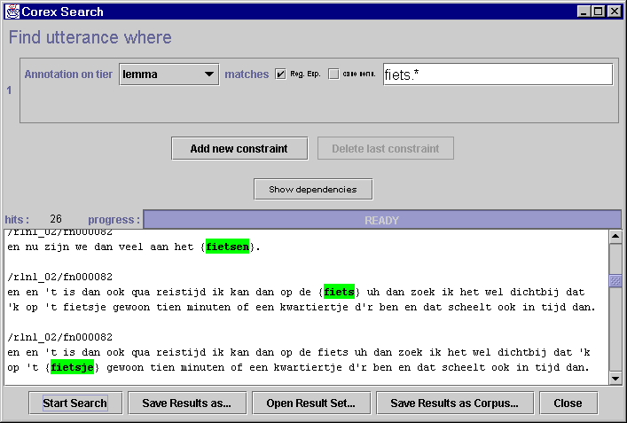
Search term
Regular expression search
Hits

The example below illustrates a more complex regular expression search that would find all instances of the stem “maak”, i.e., including “maakte”, “gemaakt”, “maak” etc.
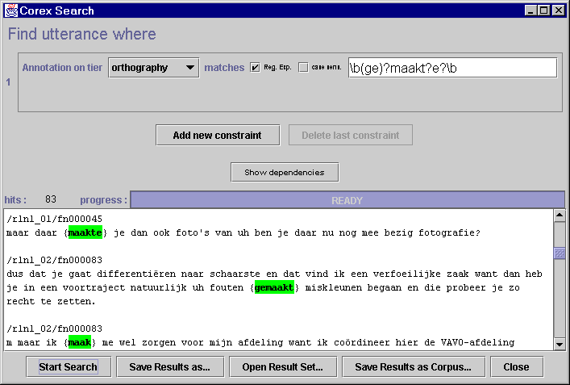
\b = matches a word break
(ge) = “ge” is treated as one character
? = matches either the preceding character or zero
Hits

To enable a regular expression search, do the following:
- Enter the search term(s) in the text field box
- Click in the box to the left of Reg. Esp.
A checkmark appears in the box indicating that this option has been selected.

Case-Sensitive Search
By default, any search is case insensitive. If you want to conduct a case-sensitive search, do the following:
- Enter the search term(s) in the text field box (paying attention to upper and lower case letters).
- Click in the box to the left of Case Sens.
A checkmark appears in the box indicating that this option has been selected.
E.g., in the following screenshot, only those instances of the search term“Het” are found that start with an upper case letter.
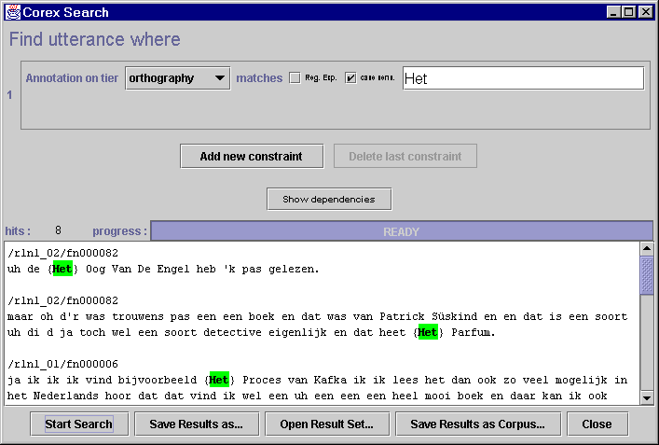
Case-sensitive search
Search term
Hits

Add new constraint button
The Add new constraint button allows you to modify the initial search parameter by adding other parameters. You can add as many parameters as necessary.
To add search parameters, do the following:
- Specify the first search parameter (as described in sections 5.1 to 5.3).
- Click on the button Add new constraint. A new constraint is added.
- Specify the second search parameter (as described in sections 5.1 to 5.3).
- Specify the relation between the first and the second parameter, i.e., specify how many words or utterances should intervene between the first and the second parameter.
For example:
- If you specify “in distance of 0 to 0 words from annotation found in 1” (as in the screenshot below), Corex will find only those words that match both the first and the second parameter (e.g., it finds all the words “die” that belong to the part of speech “VNW (betr, pron, …)”).
- If you specify “in distance of 0 to 0 utterances from annotation found in 1”, Corex will find all those utterances that match both the first and the second parameter (e.g., it finds all utterances that contain the word “die” and that contain the part of speech “VNW (betr, pron, …)”).
! Note: The default setting is “utterances”. If you search for a word that should match both search parameters, please make sure to select “words” instead.
If you want to add further constraints, repeat steps (2) to (4) above.
The following screenshot illustrates a search for the word “die” (first search parameter) of the part of speech “VNW (betr, pron, …)” (second search parameter). Corex finds only those words that match both parameters.
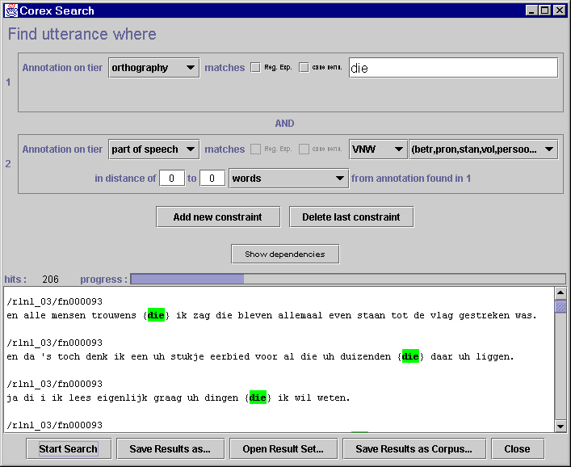
Specify the first search parameter.
Specify the second search parameter.
Click here to add further parameters.
Specify the relation between the first and second parameter.

Delete last constraint button
Click this button to remove the last constraint. It is deleted without further warning.

Show dependencies button
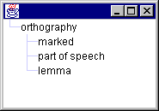
Click on Show dependencies to view the dependency relations between tracks or tiers, e.g.:

Start/Stop Search button
Click the Start Search button to conduct a search for the term(s) you are looking for. During a search, the Start Search button switches to a Stop Search button that allows you to stop a search in progress.

Save Results As … button
Click the Save Results As … button to save the results of your search. A dialogue box will open that prompts you to select the directory in which to save the file. Please save it as a Search Result File (*.res).
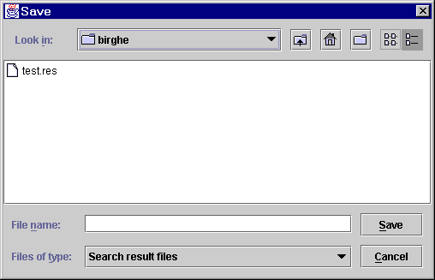
Save the results as a Search Result File (*.res).

The result file contains all possible information on the hit. The format of this file is illustrated in Appendix A. This file can, for instance, be used as a basis to extract all audio segments corresponding to the query results from the audio files.

Open Result Set … button
Click the Open Result Set … button to open a file that was saved with the Save Results As … button (i.e., saved as a Search Result File, *.res). A dialogue box will open that prompts you to browse to the desired file.
! Note: Any opened *.res file will be displayed exactly as a normal search result, i.e., the locations of the hits are given, the hits are displayed in green colour and double-clicking on any hit will automatically open up the corresponding Corex Viewer.

Save Results As Corpus … button
Click the Save Result As Corpus … button to save all sessions that contain the search results as a corpus node in the Corpus Browser window. You are then asked to specify a name for the new corpus, e.g.:
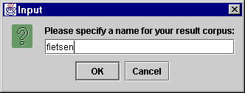

Click OK to save the specified corpus under the node Search Results in the Corpus Browser window (see section 1.2). The Meta Descriptions Tree panel will display the new corpus node, e.g.:
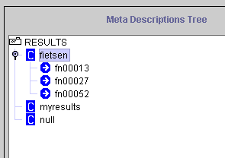
New corpus node containing the search results

This new corpus node is treated like any other corpus node: it contains sessions (those sessions where the search term was found), and the sessions contain metadata descriptions and give access to the Corex Viewer, the TIGERGraph Viewer, the Audio Player and the Wave Panel.
You can remove the saved corpus node again. Go to the node in the Meta Descriptions Tree panel. Click on it to highlight it. Then right-click on the highlighted node and select Remove from the drop-down menu.
! Note: After selecting Remove, the icon of the removed node remains visible although it cannot be accessed anymore. The icon will be removed after exiting the node Results.

Close button
When you are finished with the search, click on the Close button to close the Content Search panel and return to the Corpus Browser window.

Statistics Panel
The Statistics panel allows you to count occurrences of a term throughout the Corpus Gesproken Nederlands (CGN). To access the Statistics panel, click on the button Statistics in the Browser Action panel (see section 1.5). The Statistics panel looks as follows:
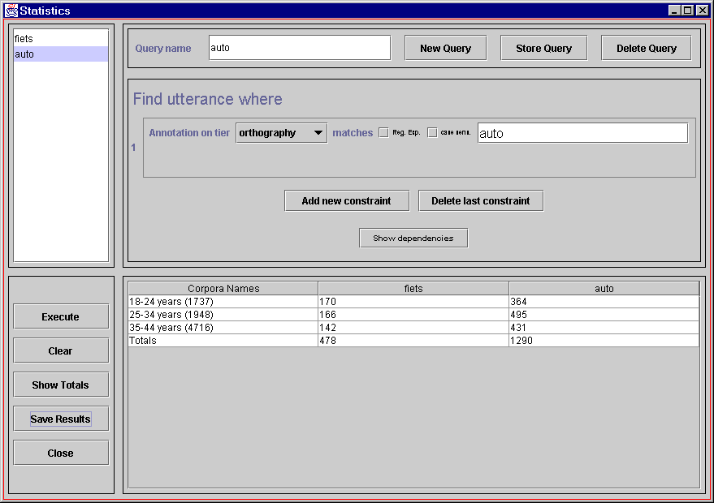
Enter the search term in the text field box. See section 5 for the available search options.

Enter a name for the query.

Click here to add, store or delete a query.

Stored queries.

Results of the statistical search.

To conduct a statistical search, do the following:
- In the Meta Descriptions Tree panel, select the corpus or corpora that you want to search (see section 1.1.3).
- In the Statistics panel, enter a name for your query into the box Query name.
- Specify your search options and enter the search term in the text field box (see section 5 for details on how to specify your search options).
- Click on the button Store query. The query will be stored and displayed in the box at the left side of the Statistics panel.
If you want to add further queries, click on the button New query, and repeat steps (2) to (4) above.
If you want to delete a query, click on the corresponding query displayed in the box at the left side of the Statistics panel. Then click on the button Delete query. The query is deleted without further warning.
If you want to delete all queries, click on the button Clear. All queries are deleted without further warning.
- Click on the button Execute to start the search.
The selected corpus or corpora is/are searched for the number of occurrences that match your query. During the search, the Execute button switches to a Stop Execution button that allows you to stop the search in progress.
The results of the search are displayed in a table format, separately for each query and each corpus. E.g., in the screenshot above, the occurrences of “fiets” and “auto” are counted separately for each specified corpus (i.e., for the corpus “18-24 years (containing 1737 sessions)”, for the corpus “25-34 years (containing 1948 sessions)” and for the corpus “35-44 years (containing 4716 sessions)”).
- Once the search is completed, you have the following options:
- Click on the button Show Totals to view the total number of matches for each query.
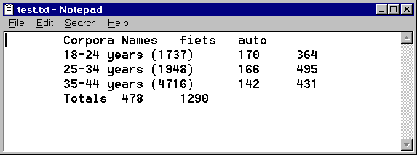
- Click on the button Save Results to save the results, e.g.:
The saved file can be opened in any program that can handle tab-delimited texts, e.g., in Microsoft Excel.
- When you are finished with the statistics search, click on the Close button to close the Statistics panel and return to the Corpus Browser window.

Appendix A
An example of the format of the search result file (see section 5.8) is as follows:

hitNr: 0
fileName: /home/broeder/COREX4/Corpora/cgn/annot//r5vl_01/sea/fv601274.sea
tierName: V60196
trackType: ORT
utteranceNr: 2
ortContent: aan de ene kant mensen die handjes schudden groepsfoto's laten maken met fiets zonder fiets en voor de rest vergaderen.
hitWordNr: 0
hitBeginPos: 73
hitEndPos: 78

hitNr: 1
fileName: /home/broeder/COREX4/Corpora/cgn/annot//r5vl_01/sea/fv601274.sea
tierName: V60196
trackType: ORT
utteranceNr: 2
ortContent: aan de ene kant mensen die handjes schudden groepsfoto's laten maken met fiets zonder fiets en voor de rest vergaderen.
hitWordNr: 0
hitBeginPos: 86
hitEndPos: 91

